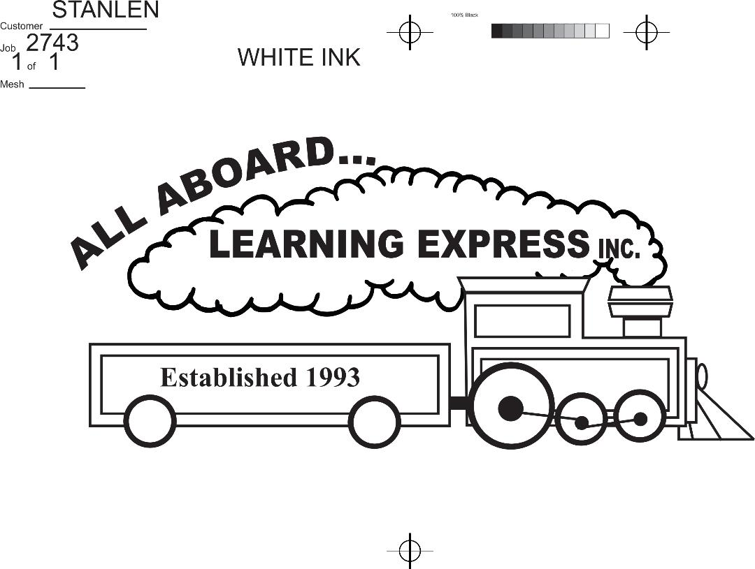

4008 W. Rosemont Ave.
Chicago, IL 60646
(773) 202-0554
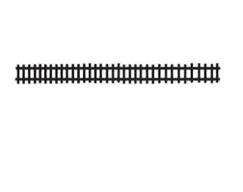
allaboardlearningexpress@yahoo.com

INFANT/TODDLER -Opening August 2026

INTRODUCTION TO PRESCHOOL
PRESCHOOL

PRE-K/JR. KINDERGARTEN/KINDERGARTEN
Summer 2026/School Year 2026-2027

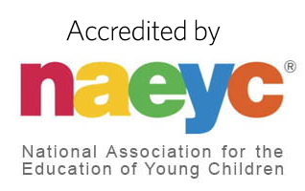
TABLE OF CONTENTS

PHILOSOPHY …………………………………………………………………………..Page 2
PROGRAMS………………………………………………………………………………Page 3
DAILY SCHEDULES…………………………………………………………………...Page 4-5
WHAT TO WEAR/BRING……………………………………………………….Page 6
PROCEDURES………………………………………………………………………….Page 7
HEALTH REGULATIONS………………………………………………………...Page 8-9
EMERGENCIES………………………………………………………………………..Page 10
POLICIES…………………………………………………………………………………Page 11-12
INFANT PROGAN POLICIES AND PROCEDURES………………Page 13-15
RATES FOR SERVICES…………………………………………………………...Page 16-17

__________________________________________________________________________________________
Candace Marie Mayr (773) 202-0554
Director (Teacher) Owner 4008 W. ROSEMONT AVE.
CHICAGO, IL
Fax (773) 202-1553

Website: www.allaboardlearningexpress.com
Email: allaboardlearningexpress@yahoo.com
PHILOSOPHY
ALL ABOARD…LEARNING EXPRESS, INC. PROVIDES A STAFF, PROGRAM, AND ENVIRONMENT TO ENHANCE THE GROWTH AND DEVELOPMENT OF YOUNG CHILDREN
Each child is a special little human being. Understanding and meeting his/her needs is of utmost importance to us. It is imperative to work closely with parents in a complimentary manner in order to accomplish this fully.
We are dedicated to the goal of providing programs for total child development. Research has firmly established the importance of emotional, social, intellectual, and physical development during children’s early years. In our programs, all items in curriculum are related to the developmental levels of our children.
Emotional Development is accomplished by nurturing each child toward an inner sense of trust and autonomy. Our goal is the development of a positive self-image in order that the young child experiences good feelings about himself/herself and his/her world.
Social Development is accomplished by helping the young child to develop a feeling that he/she is an independent little person and yet be able to accept help and guidance from teachers and peers. Our goal in teaching is to help him/her develop self-control and the ability to participate with group members in a cooperative and satisfying manner. Emotional and social development are the foundation blocks which make it possible for a child to utilize his/her intellectual capacities.
Intellectual Development includes firsthand experiences in grasping appropriate concepts which will enable him/her to think and reason as he/she faces the challenge of each new task. Intelligence is measured by the number of ideas a child possesses.
Physical Growth is achieved by the development of muscle groups. An appropriately planned motor development program is provided.
In summary, All Aboard…Learning Express, Inc. is an environment where each child can develop to his/her fullest potential in each of the aforementioned areas.

PROGRAM
Our daily program is devoted to both the needs and interests of the individual child and the group. We feel that children of the age group we are teaching should have a relaxed program with as much freedom as possible in his/her daily schedule. Our programs are purposely flexible so each child works and plays at his/her own pace. He/she has many choices of activities within the environment planned for his/her age group. Each phase of our program is planned with an objective in mind.
Our objectives are:
- To provide quality developmental care for each child in our program by aiding the child in discovering a sense of his/her own self-worth and knowing that his/her ideas and feelings are important.
- To surround the child with staff members of integrity and imagination. Each have a genuine concern for and sensitivity towards all children.
- To provide a learning environment for every age group, thus encouraging maximum growth of the whole child. We offer a planned educational program, for children ages 6 weeks through 8 years of age, using a thematic approach. Art, Music, Dramatics, Science, Literature, Language, Math Concepts, Motor Development, and Laughter play a major role in the daily program.

Classroom activities are balanced between outdoor “free play” and supervised learning centers, designed to stimulate and challenge young minds and bodies.

DAILY SCHEDULE
INFANTS/Toddler
7:00 A.M-8:30 A.M. Slow Arrival/greetings/parent communication
8:30 A.M. -11:00 A.M. Tummy time/outside time/push and pull toys/exploration/
Snack/sensory time
11:00 A.M. – 1:00 P.M. Nap/lunch
1:00 P.M. -3:30 P.M. Language development/story time/tummy time/music and singing
3:30 P.M. – 6:00 P.M. singing/play time/departure
6:00 P.M. Center Closes
Diapering and feeding are based on the needs of each infant and is supervised by a teacher/staff member at all times.
**Age appropriate naps will vary
INTRODUCTION TO PRESCHOOL
7:00 A.M. Slow Arrival, Supervised Activities
8:00 – 8:45 A.M. Breakfast, Arrival
8:45 – 10:00 A.M. Clean Up, Circle Time
10:00 – 11:00 A.M. Wash Hands, Snack
11:00 – 12:00 P.M. Centers
12:00 – 3:00 P.M. Wash Hands, Lunch, Nap Time
3:00 – 4:00 P.M. Wake Up, Afternoon Snack
4:00 – 6:00 P.M. Group Time, Story Time, Art, Centers, Free Play
6:00 P.M. Center Closes

PRESCHOOL
7:00 A.M. Slow Arrival, Supervised Free Choice Activities
8:00 – 8:30 A.M. Separation of Age Groups and Breakfast
8:30 – 8:45 A.M. Arrival
8:45 – 9:00 A.M. Clean Up Time
9:00 – 9:10 A.M. Good Morning Circle/Calendar
9:10 – 10:00 A.M. Art Project/Cooking
10:00 – 10:25 A.M. Clean Up Time
10:25 – 10:40 A.M. Wash Hands, Snack
10:40 – 11:15 A.M. Large Motor/Yoga/Dancing/Workout
11:15 – 12:00 P.M. Science/Math, Music, Spanish, and Storytime
12:00 – 12:30 P.M. Wash Hands, Lunch
12:30 –1:00 P.M. Take out Cots, Take off Shoes
1:00 – 3:00 P.M. Nap Time
3:00 – 3:30 P.M. Put Away Cots and Afternoon Snack
3:30 – 4:00 P.M. Group Activity or Group Games, Story
4:00 – 6:00 P.M. Free Play/Open Art/ Group Games/ Outdoor Play
* Schedule may be slightly adjusted to fit the needs of individual classrooms.
*All Aboard…Learning Express, Inc. implements Illinois Early Learning Standards in our daily curriculum.

DAILY SCHEDULE
PRE-K &Jr. KINDERGARTEN/KINDERGARTEN
7:00 A.M. Supervised Free Choice Activities
8:00 – 8:45 A.M. Division of Age Groups and Breakfast
8:45 – 9:00 A.M. Morning Meeting: Attendance, Pledge, Calendar, and Weather
9:00 – 10:00 A.M. Phonics/Reading
10:00 – 10:15 A.M. Snack
10:15 – 11:15 A.M. Math/Centers
11:15 – 12:00 P.M. Writing/Spelling/Centers
12:00 – 1:00 P.M. Lunch/Recess
1:00 – 1:30 P.M. Social Studies/Science
1:30 – 2:30 P.M. Music/Art/Yoga/Technology/Spanish
2:30 – 2:45 P.M. Homework/Dismissal
2:45 – 6:00 P.M. Afterschool Program: Group Games, Cooking, Science Experiments, Crafts, Music, and Outdoor Play
6:00 P.M. Center Closes
*All Aboard…Learning Express, Inc. implements Illinois Early Learning
Standards, Daily 5, and Daily 3 into our curriculum.
*Rest Period

WHAT TO WEAR & WHAT TO BRING
What does the well-dressed child wear to All Aboard…Learning Express, Inc.? “In fashion” means washable clothes –preferably comfortable, sturdy, washable play clothes. Painting, gluing, mud., etc. are always available here at AALE, and whether you wash with Tide, All, or Wisk, some colors of paint just won’t wash out. To decide if he/she is “in fashion” or appropriately dressed, before leaving home ask yourself, “Will I be upset if he/she comes home with dirt, paint, or chocolate pudding on this outfit?” If the answer is yes, please change to more appropriate clothing.
Clothing that is easy to manage encourages independence and self-help skills. Many toilet accidents are prevented if children can unbutton or unbuckle pants and belts without a struggle.
All jackets, sweaters, coats, hats, boots, and umbrellas must be clearly marked with your child’s name. Many children wear identical clothing, and without a name in each garment, it is almost impossible for teachers to identify to whom it belongs. If you send a hat, gloves, etc. with your children, we will have them wear the item when going outside. Please do not leave plastic bags on hooks as a safety concern.
What to Bring:
- A change of clothes: Pants, shirt, or dress, socks, inside shoes and underwear. Child’s name must be on each item.
- Birthdays and Holiday Parties: Due to severe food allergies, religious diets, and/or dietary restrictions All Aboard…Learning Express, Inc. has chosen to celebrate these occasions with no outside food. Please see your child’s classroom teachers for any non-edible treat ideas. These will be sent home.
- Gym shoes must be worn at all times. Sandals, boots, crocs, slippers, backless shoes, and dress up shoes are not acceptable safety wear. A pair of gym shoes need to be left at school as inside shoes.
- Infants, Toddlers, and Introduction to Preschool classrooms will need: diapers, wipes, creams (with a doctor’s note), extra clothes, bibs and bottles. See Infant section for more detailed information.

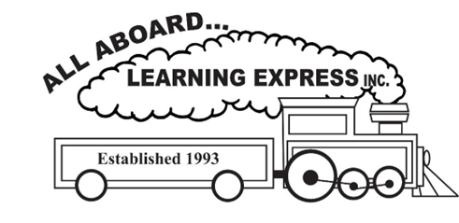
PROCEDURES
ARRIVAL AND DEPARTURE:
Upon arrival, the responsible adult must walk with the child to their classroom after changing from their outside to inside shoes. The adult must wait for the child’s temperature check and they are asked to add the temperature to Lillio sign in. Children will be released ONLY to those persons whose names are listed on their application. All Aboard…Learning Express, Inc. employees will require proof of identification from anyone we do not recognize. Any individuals picking up must be 18 years old or older.

SAFE DOOR POLICY:
Our school has a closed-circuit system on our front door. In order for anyone to be allowed into the school, a staff member needs to individually buzz them in. This is emphasized to ensure the safety of each student. Therefore, please do not allow another individual to enter with you upon your arrival or departure.
DISCIPLINE:
We strive to develop a positive relationship between our staff and the child as an individual person. It is our belief that if an interesting and challenging program is offered to the child, then discipline problems will be at a minimum. If a discipline problem does arise, a positive approach is used, praising the child’s good behavior and/or redirecting his/her activity. Redirecting is the primary approach used. If redirecting does not work and the behavior continues, he/she may be seated at an activity table to slow down a minute or two. The key to effective discipline is consistency. The staff does try to be as consistent as possible. A detailed Guidance and Discipline form is to be read and signed upon enrollment.
FIELD TRIPS:
Supervised field trips may be scheduled to local points of interest. Parents or guardians must complete and sign our application that includes a field trip permission portion when needed.

RELEASE OF CONFIDENTIAL INFORMATION:
Personal information regarding your child is kept confidential. Any information such as emails, phone numbers, and addresses, which may be needed for social events, will only be released with written waiver.
LILLIO
LILLIO is an app for parents and teachers to communicate regarding all classroom related happenings. Parents are able to sign-in, check photos, receive daily reports and message teachers. If you have a question regarding tuition, policies, or something that needs immediate attention, please email the office.

HEALTH REGULATIONS

It is important that every parent cooperates fully with the school health program. Our regulations are designed to protect the well-being of all children and to guard against avoidable absence for health reasons. When there are symptoms of illness or other indications that a child is not well enough for group activities, arrangements must be made for his/her care at home. All Aboard…Learning Express, Inc. has no provisions for the care of children who are ill. Proper care at the beginning of an illness can often shorten its duration.
Exposure to communicable diseases, infectious illnesses or other ill family members should be promptly reported so that the teachers may be alerted to early symptoms. By the same token, the teachers will notify each parent when a child has been exposed to an infectious disease. Prescribed and “Over the Counter” medicine will only be administered if a parent signs a consent form accompanied by a doctor’s note.
GETTING SICK AT THE CENTER:
Whenever a child becomes ill the parents will be notified right away. The sick child will be isolated from the rest of the children and wait for the parents to pick him/her up.
Symptoms that indicate possible disease or infection may include:
Unusual Behavior: Crying for no apparent reason, a placid child becomes very active, the energetic child becomes listless, the happy child becomes cranky, or the child is just not himself/herself.
Changes in Skin Color or Texture: Skin may look red, pale, or yellow, may have unusual spots or rashes, or may itch. The whites of the eyes may be red or yellow, or may begin to tear. There may be a discharge from the eyes.
Respiratory Difficulties: Green or yellow discharge from the nose usually indicates infection. Sniffles, stuffy nose, coughing, or wheezing indicate something is wrong.
Intestinal Disturbance: Diarrhea or loose stool, change in frequency of bowel movements, or an unusual color or odor may be indicators of a problem. After two (2) loose stools, the parent is called and told of the problem. After the third (3rd) loose stool, the child is isolated to wait for the parent to pick him/her up. The child must have a “normal” or solid stool for 24 hours before returning to school. Stomach issues can last for days, therefore, if a child is sent home for vomiting, they must be free of vomiting for 24 hours before they can return to school.

HEALTH REGULATIONS

Rash: Any undiagnosed rash.
Eyes and/or Ears: Any sore or discharging from eyes or ears. Eyes that are crusty or red in appearance.
Lice: Small, flat, wingless insects that live on the scalp. Highly contagious, therefore the child must be nit free before returning to school.
When a child has been absent for a simple cold, he/she may be re-admitted to school with approval of the director. Following an illness accompanied by a rise in temperature, a child must be excluded from school and fever free for 24 hours without fever reducing medication, before returning to school.
A child will be sent home when the illness requires more care than the staff can provide without compromising the needs of the other children in the group.
A doctor’s note stating safe return to school and a diagnosis will be required for contagious diseases such as, but not limited to, the following:
- Chicken Pox
- Strep Infection
- Any Rash
- Conjunctivitis
- Impetigo
- Bronchitis
- RSV
*In our best efforts to try to limit the spread of illness, if two or more doctor confirmed cases are reported, a note will be sent home to families. In addition, we continue to monitor temperatures twice a day to help identify illness early to limit the spread of cold/flu. We reserve the right send your child home or mask them when they exhibit an excessive runny nose that cannot be contained and risks the spread of bodily fluids in the classroom.
MEDICAL FORM:
In the best interest of your child’s health and the health of all children enrolled at our school, you are required to submit your child’s current medical immunization forms prior to his/her first day at school. These forms must be updated yearly in compliance with the state. In addition to yearly vaccines mandated by the State of Illinois Department of Health, a lead test with a lead level result, a TB test, Hearing/Vision screening results, and a chicken pox vaccine must be included and on file prior to your child’s first day of school. Hearing and vision screenings are required for children 3 years and up. All medicals must be signed (not stamped) by your child’s doctor.

EMERGENCIES
MEDICAL:
Included in the registration paperwork is the child’s application and medical. We want to make certain that your child is protected. If your child is injured, our first step is to administer first aid if necessary. Next, we will contact you. In the event your child requires immediate medical attention, we reserve the right to take your child to the nearest hospital before contacting you. If a child cannot receive medical attention due to religious reasons, parents should list who should be called instead of a doctor. Parent’s insurance information is required to be on file.
DIETARY RESTRICTIONS:
The safety and education of our students at AALE is our top priority. Due to the high volume of children with certain food allergies, religious diets, and/or dietary restrictions, AALE is a nut free facility which limits outside food items from being brought into the building. If your child requires a special diet from home, it will need to be accompanied by a doctor’s note.
FIRE AND NATURAL DISASTER:
Our center has special procedures set up to deal with such emergencies as fire and natural disasters. Our center is inspected on a regular basis by the City Fire inspector. Fire and tornado drills are held regularly and a logbook is kept. During severe weather a constant check is kept for emergency information.
CHANGE OF ADDRESS OR PHONE NUMBER:
It is very important that we have your current email, address, and phone numbers. In case of accident or illness we need to be able to contact you at home or at your place of employment. Please notify the admission office of any changes when they occur.
QUESTIONS OR CONCERNS YOU MAY HAVE:
When questions and concerns arise, please feel free to call or email the school office. If the school is closed or if we are on another call, you will be directed to voice mail. Please leave a detailed message and we will return your call as soon as possible.
REQUEST FOR TAXES/DOCUMENTS/TRANSCRIPTS/MEDICALS:
Please list items requested in writing and allow one week to be completed by administration.

POLICIES
- All Aboard…Learning Express, Inc. is licensed by the Department of Child and Family Services. DCFS requires that all children enrolled at our early childcare facility must be at least 6 weeks old. Only our Infant/Toddler and Intro to Preschool classrooms are equipped with a changing table, therefore, it is imperative that your child be fully potty trained before entering our Preschool classroom.
- DROP OFF TIME – Between 7:00 a.m. – 9:00 a.m. Late arrival may result in your child missing out on that day’s art project, participating in all of the scheduled activities, and they are marked tardy for the day.
- ABSENCE – No monetary allowances shall be made for absences, vacation, or holidays.
- WITHDRAWAL – If any child in any program withdraws prior to the end of its completion, they will forfeit their security deposit. The security deposit is applied to the last two weeks of the program. Withdrawal from the program must be made in writing. You are still responsible for payment through your child’s last day of attendance and/or until written notice is received.
- FUNDRAISING – All Aboard…Learning Express, Inc. makes every effort to keep our tuition costs as low as possible while maintaining the highest level of quality. Fundraisers help us maintain these high standards at our school. Families are required to participate in a fundraiser each year and to raise a minimum amount towards our goal. Families who do not participate will be required to a tuition increase that is equivalent of our fundraiser goal per child. Your support is greatly needed and much appreciated. The current required family goal is set at $50.00 profit to our school for each enrolled child.
- LATE CHARGES – Tuition payments are due Friday and are considered late after Monday at 12:00 pm (noon) and will be charged $10.00. If no payment is received within one week, your child’s attendance will be interrupted until full payment is made.

- DISCHARGE – Occasionally a child will experience difficulty in adjusting to a school setting and/or abiding by certain rules of behavior in the classroom. If a child is experiencing some difficulty, you will be notified and a conference will be scheduled. We will work closely with you to see if the problem can be resolved. As a last resort, we reserve the right to ask you to withdraw your child from our program. The safety and wellbeing of every student at AALE is the of the utmost importance and will remain our number one priority.
POLICIES (continued)

- LATE PICKUP – Our hours of operation are 7:00 a.m. – 6:00 p.m. At 6:06 p.m. you will be charged a $10.00 fee and a dollar every minute after that.
- DAYS CLOSED DURING THE YEAR ARE AS FOLLOWS:
- Labor Day – Closed
- Thanksgiving and the day after – Closed
- Christmas Eve and Christmas Day – Closed
- New Year’s Eve and New Year’s Day – Closed
- Martin Luther King Day/ Teacher Institute Day – Closed
- Good Friday – Closed
- Memorial Day – Closed
- Independence Day – Closed
If a scheduled closing day falls on a Saturday or Sunday, then our program observes a day off on the following Monday.
These holidays are not deducted from weekly payments.
The last day of school year and our annual block party will be held on a Friday in June. There is no school on the day of the block party. Parent/Guardian supervision is required at the block party. Summer camp starts immediately on the following Monday.
- BABYSITTING – All Aboard…Learning Express, Inc. does not promote or consent for their employees to provide care and/or employ themselves with outside babysitting/caretaking jobs for families enrolled at All Aboard…Learning Express, Inc.

- WATER BOTTLES – AALE requires that students bring a water bottle each day. The perfect water bottle should be labeled with your child’s name, leak-proof, unbreakable, and safe. The water bottle must also have a type of flip-open top. For safety reasons, no one-time use water bottles with disposable caps are allowed. The water bottle must contain water and water only. Water bottles must be taken home on a daily basis to be cleaned and sterilized. Staff will refill water bottles throughout the day at our filtered bottle filling station.

- EXTRA CLOTHING BAG – A change of clothes: Pants, shirt, or dress, socks, inside shoes and underwear need to be provided. Child’s name must be on each item. Please be sure that clothing appropriate for each season. For health and hygiene reasons, we are not able to leave children in soiled clothing and we are not able to borrow clothes from another non-related child in the building. If a change of clothes has not been provided or replenished and the parents are unable to arrive in a reasonable amount of time, we will assist the child the best we can until the parents arrive.
INFANT PROGRAM
6 WEEKS THROUGH 14 MONTHS
Shoeless environment for all individuals entering the room. Only infants shall be barefoot in the classroom.

Infant Sleep Policy: no weighted blankets, lovies, stuffed animals or pacifiers with cords or stuffed animals.
All Aboard…Learning Express, Inc. will follow the listed guidelines from the American Academy of Pediatrics regard safe sleep policies. Theses guidelines were developed to reduce the risk of SUID ( Sudden Unexplained Infant Death Syndrome) which includes SID (Sudden Infant Death Syndrome)
- Place infants on their backs for sleep in their own sleep space with no other people.
- Use a crib, bassinet or portable play yard with a firm, flat mattress and a fitted sheet. Avoid sleep on a couch or armchair or in a seating device, like a swing or car safety seat (except while riding in the car).
- Keep loose blankets, pillows, stuffed toys, bumpers and other soft items out of the sleep space.
- Breastfeed if possible and avoid smoking.
All children under 15 months of age are required to sleep in a crib. Children 15 months of age and older can transition to cot.
Sleep time for each infant will be determined by the schedule set with each family. Cribs are utilized for children needing sleep or rest time and will not be utilized simply contain a child.
All infants who arrive to school in a car seat asleep, will be removed from the seat and placed in their crib for safe sleep protection.
All Aboard…Learning Express, Inc. Administration will ensure that all infant staff are properly trained annually in the Infant Safe Sleep Policy, SIDS and SUID, as well as Safe Bay, Safe Child, in addition to other safety courses offered and or required by DCFS.
Sleep sacks and swaddle sacks are allowed for infants per safe sleep procedures. All sleeping infants shall be placed in their own cribs on their backs for nap time. Teachers will be positioned to observe all sleeping children and check each child often during sleep time. Staff are required to keep the room well lit to allow clear visuals of each child.
Per DCFS Licensing Standards:
To minimize the risk of sudden infant death syndrome, children shall be placed on their backs when put down to sleep according to the following guidelines:
1) When the infant cannot rest or sleep on his or her back due to a disability or illness, the caregiver shall have written instructions, signed by a physician, detailing an alternative safe sleep position or special sleeping arrangements for the infant. The caregiver shall put the infant to sleep in accordance with a physician's written instructions;
2) Infants that can easily turn over from the back to stomach position shall be placed down to sleep on their backs, but allowed to adopt their preferred position while sleeping;
3) Infants unable to roll from their stomachs to their backs and from their backs to their stomachs, when found facedown, shall be placed on their backs;
4) No infant shall be put to sleep on a sofa, soft mattress, car seat or swing;
5) When awake, an infant shall be placed on his or her stomach part of the time and observed at all times.

Tummy Time:
Tummy time will be supervised at all times and will only occur while the child is awake. Each child will receive tummy time at least once a day depending on the amount of hours in attendance/awake time. Tummy time will approximately 3 to five minutes at a time.
Children will not receive tummy time in a crib.
Infant Feeding Policy:
Parents are responsible for breast milk & formula as well as pureed baby food. All bottles and cups should be labeled with the child’s first and last name and the date, each day.
Staff and families will discuss and log their families feeding schedule and routine to help keep the child’s routine normal and familiar.
Core Feeding Requirements per IDHS

- Bottle Safety: Infants must always be held while being fed. Bottle propping is prohibited to prevent choking and ear infections.
  - Bottles will not be given to a child while laying in their crib.
- Hygiene: Staff and children must wash their hands before every feeding. Surfaces of high chairs or feeding tables must be cleaned and sanitized after each use.
- Storage & Disposal:
  - Leftover formula or breast milk from a feeding must be discarded.
  - Prepared formula not used within 24 hours must be discarded.
  - Foods served from a jar or pouch must be placed in a separate dish; any leftovers in that dish must be discarded. This eliminates the possibility of contamination to the remaining food from the child’s saliva.
  - Any remaining, food, formula, or breastmilk will be discarded at the end of each day.
Formula and Breast Milk Storage and labeling:
- All formula and Breastmilk bottles should be brought in daily and labeled with your child’s full name and date of preparation.
- Glass bottles are permitted if covered in a silicon sleeve.
- Formula, breastmilk, and milk are the only liquids allowed to serve in bottles.

- Milk Regulations: Human milk or iron-fortified formula is required for children under 1 year. Whole milk is typically served between ages 1 and 2 unless otherwise directed by a medical provider. Honey is strictly prohibited for infants.
Introduction of Solids
- Age Appropriateness: Solid foods or juices should not be introduced until at least four months of age.
- Developmental Readiness: Guidelines emphasize following the child's developmental cues. By 12 months, children should be eating most foods from the table.

Solids and table foods are required to be introduced at home before given to a child at All Aboard…Learning Express, Inc.

What to Bring for Infants:
- Extra clothes
- Swaddle
- Diapers and wipes (No cloth diapers)
- Diaper cream
- Pacifier (not attached to any string, ribbon, or toy)
- Parents will be asked to launder crib sheets twice a week for full time care.
- A minimum of 5 bibs a week

Summer Camp 2026 Rates for Services
Children from age 6 weeks through 8 years may be enrolled in our Full Day Summer Camp program. Rates include breakfast, morning snack, lunch, and afternoon snack

INFANT 6 weeks through 14 months
$100.00 registration fee per child (non-refundable)
Full 5 days enrollment rate is $495.00 per week
Mon./Wed./Fri. enrollment rate is $375.00 per week
Tues./Thurs. enrollment rate is $300.00 per week
An Extra Full Day rate is $105.00 per day (Must be requested on our form)

TODDLER 15 months through 2 years old
$100.00 registration fee per child (non-refundable)
Full 5 days enrollment rate is $395.00 per week
Mon./Wed./Fri. enrollment rate is $285.00 per week
Tues./Thurs. enrollment rate is $255.00 per week
An Extra Full Day rate is $95.00 per day (Must be requested on our form)

INTRO TO PRESCHOOL
$100.00 registration fee per child (non-refundable)
Full 5 days enrollment rate is $360.00 per week
Mon./Wed./Fri. enrollment rate is $270.00 per week
Tues./Thurs. enrollment rate is $235.00 per week
An Extra Full Day rate is $85.00 per day (Must be requested on our form)

PRESCHOOL, PRE-K, JR. KINDERGARTEN/KINDERGARTEN
$100.00 registration fee per child (non-refundable)
Full 5 days enrollment rate is $300.00 per week
Mon./Wed./Fri. enrollment rate is $225.00 per week
Tues./Thurs. enrollment rate is $165.00 per week
An Extra Full Day rate is $65.00 per day (Must be requested on our form)
School Year 2026-2027
Children from ages 6 weeks through 10 years old may be enrolled in our Infant/Toddler, Introduction to Preschool, Preschool, Pre-k, and Jr. Kindergarten/Kindergarten Programs. Rates include breakfast, morning snack, lunch, and afternoon snack

TUITION RATES ARE AS FOLLOWS:
INFANT 6 weeks through 14 months
$100.00 registration fee per child (non-refundable)
Full 5 days enrollment rate is $495.00 per week
Mon./Wed./Fri. enrollment rate is $375.00 per week
Tues./Thurs. enrollment rate is $300.00 per week
An Extra Full Day rate is $105.00 per day (Must be requested on our form)

TODDLER 15 months through 2 years old
$100.00 registration fee per child (non-refundable)
Full 5 days enrollment rate is $395.00 per week
Mon./Wed./Fri. enrollment rate is $285.00 per week
Tues./Thurs. enrollment rate is $255.00 per week
An Extra Full Day rate is $95.00 per day (Must be requested on our form)

INTRO TO PRESCHOOL
$100.00 registration fee per child (non-refundable)
Full 5 days enrollment rate is $360.00 per week
Mon./Wed./Fri. enrollment rate is $270.00 per week
Tues./Thurs. enrollment rate is $235.00 per week
An Extra Full Day rate is $85.00 per day (Must be requested on our form)
PRESCHOOL, PRE-K, AND JR. KINDERGARTEN/KINDERGARTEN
$100.00 registration fee per child (non-refundable)
Full 5 days enrollment rate is $300.00 per week
Mon./Wed./Fri. enrollment rate is $225.00 per week
Tues./Thurs. enrollment rate is $165.00 per week
An Extra Full Day rate is $65.00 per day (Must be requested on our form)

